

DEPARTMENT OF INFORMATION TECHNOLOGY LAB MANUAL

CS23432 – Software Construction

(REGULATION 2023)

RAJALAKSHMI ENGINEERING COLLEGE
Thandalam, Chennai-602015

Name:
ASHOK BHARATHI R

Register No: 241001020
Year / Branch / Section: II - IT Semester: IV
Academic Year: 2025-2026

INDEX
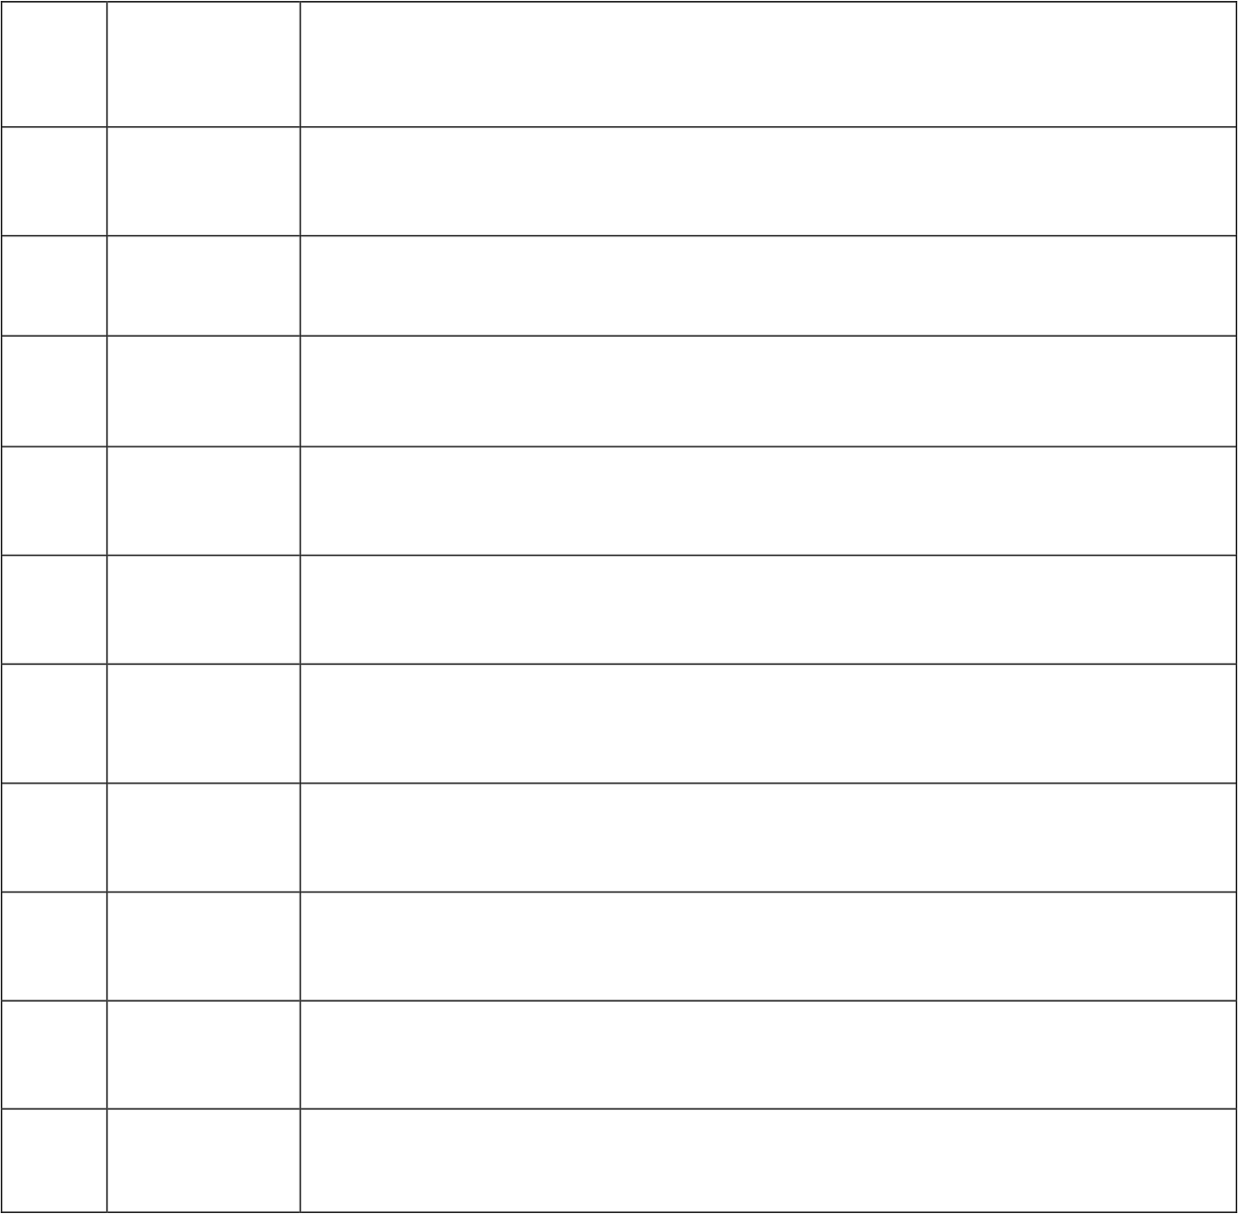
S.No
Date
Title
1.
21/01/26
Azure Devops Environment Setup.
2.
28/01/26
Azure Devops Project Setup and User Story Management.
3.
04/02/26
Setting Up Epics, Features, And User Stories for Project Planning.
4.
11/02/26
Sprint Planning.
5.
18/02/26
Poker Estimation.
6.
25/02/26
Designing Class and Sequence Diagrams for Project Architecture.
7.
11/03/26
Designing Architectural and ER Diagrams for Project Structure.
8.
18/03/26
Testing – Test Plans and Test Cases.
9.
25/03/26
Load Testing and Pipelines.
10.
08/04/26
GitHub: Project Structure & Naming Conventions.


EXPNO: 1
Create Epic,Features, User Stories, Task
AZUREDEVOPS ENVIRONMENT SETUP

Aim:
To set up and access the Azure DevOps environment by creating an organization through the Azure portal.

INSTALLATION:
- Open your web browser and go to the Azure website: https://azure.microsoft.com/en-us/get-started/azure-portal. Sign in using your Microsoft account credentials.
If you don't have a Microsoft account, you can create one here: https://signup.live.com/?lic=1

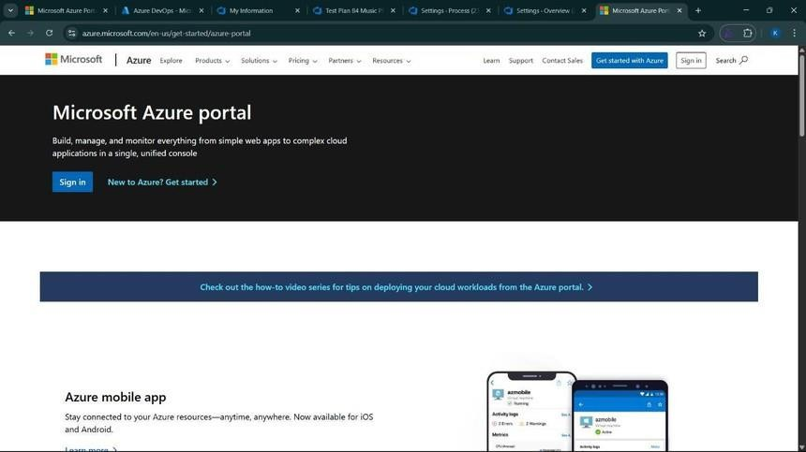

- Azure home page

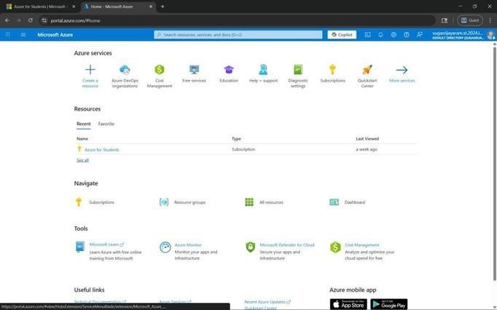

- Open DevOps environment in the Azure platform by typingAzure DevOps Organizations in the search bar.
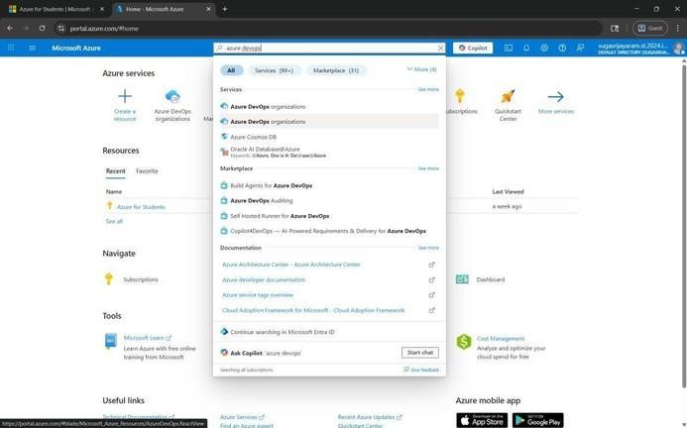

- Click on the View My Organization link and create an organization and you should be taken to the Azure DevOps Organization Home page.
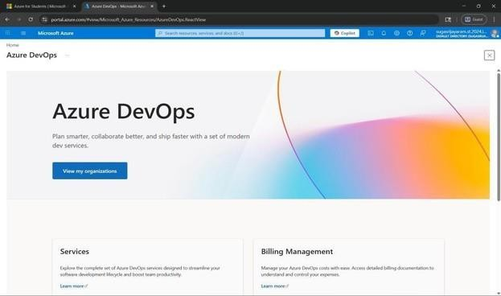

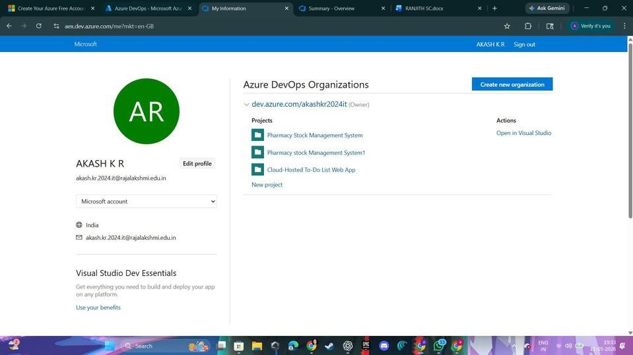

Result:

Successfully accessed the Azure DevOps environment and created a new organization through the Azure portal.


EXP NO: 2
Create Epic, Features, User Stories, Task

AZURE DEVOPS PROJECT SETUP AND USER STORY MANAGEMENT

Aim:
To set up an Azure DevOps project for efficient collaboration and agile work management.

Procedure:

- Create An Azure Account
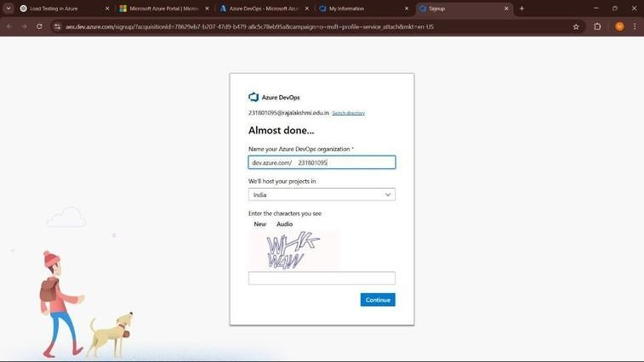

- Create the First Project in Your Organization
  - After the organization is set up, you’ll need to create your first project. This is where you'll begin to manage code, pipelines, work items, and more.
  - On the organization’s Home page, click on the New Project button.
  - Enter the project name, description, and visibility options:
Name: Music Playlist Project.
Description: The Music Playlist is an application that allows users to upload multiple music files, organize them automatically, and create playlists. Users can manage their songs, arrange playlists, and download songs securely after payment. The system also uses external APIs to fetch song metadata and improve music organization.
Visibility: Choose whether you want the project to be Private (accessible only to those invited) or Public (accessible to anyone).

  - Once you’ve filled out the details, click Create to set up your first project.
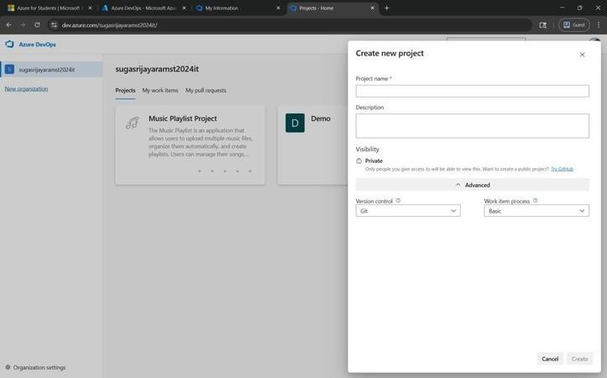

- Once logged in, ensure you are in the correct organization. If you're part of multiple organizations, you can switch between them from the top left corner (next to your user profile). Click on the Organization name, and you should be taken to the Azure DevOps Organization Home page.



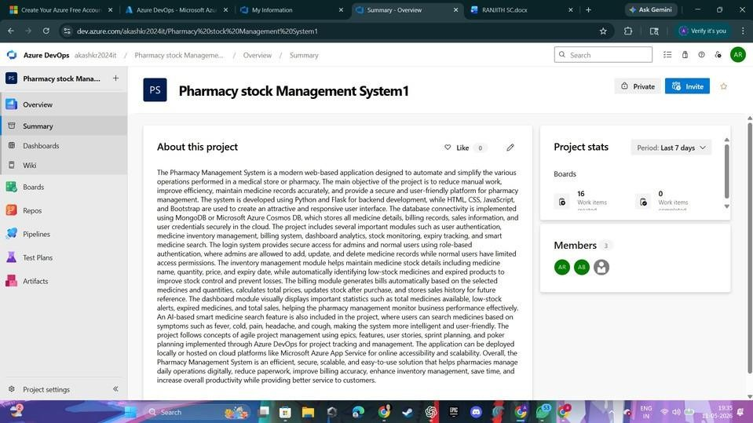
- Project dashboard

- To manage user stories:
  - From the left-hand navigation menu, click on Boards. This will take you to the main
Boards page, where you can manage work items, backlogs, and sprints.
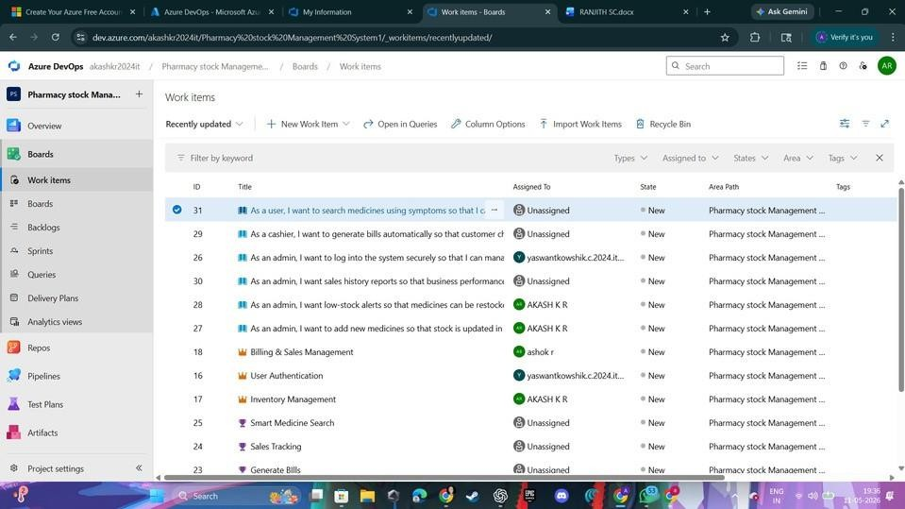
  - On the work items page, you'll see the option to Add a work item at the top. Alternatively, you can find a + button or Add New Work Item depending on the view you're in. From the Addaworkitem dropdown, select User Story. This will open a form to enter details for the new User Story.

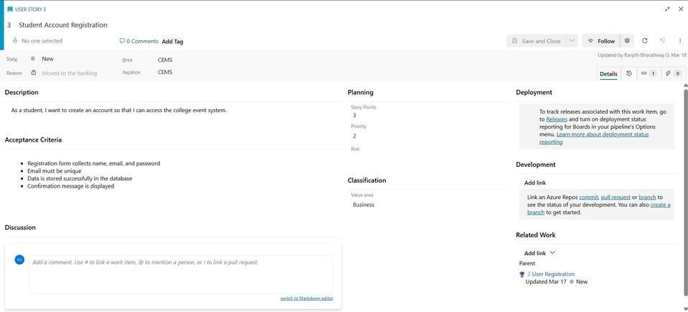

Result:
Successfully created an Azure DevOps project with user story management and agile workflow setup.


EXP NO: 3
Create Epic, Features, User Stories, Task

SETTING UP EPICS, FEATURES, AND
USER STORIES FOR PROJECT PLANNING

Aim:
To learn about how to create epics, user story, features, backlogs for college event management.

Create Epic, Features, User Stories, Task:



Fill in Epics
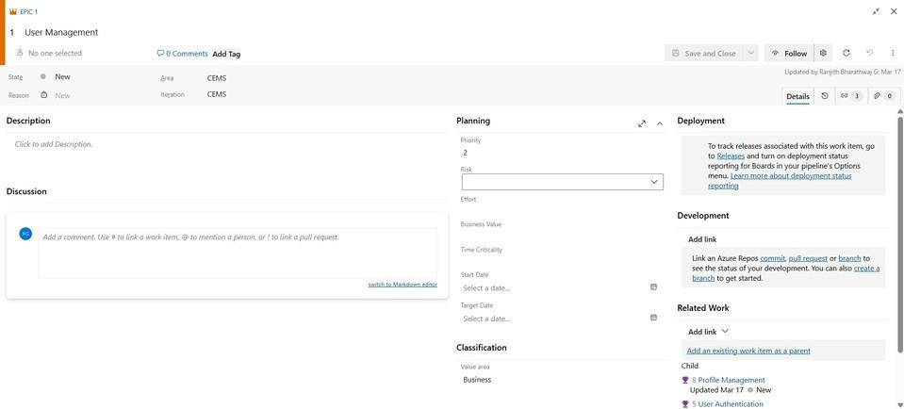

Fill in Features
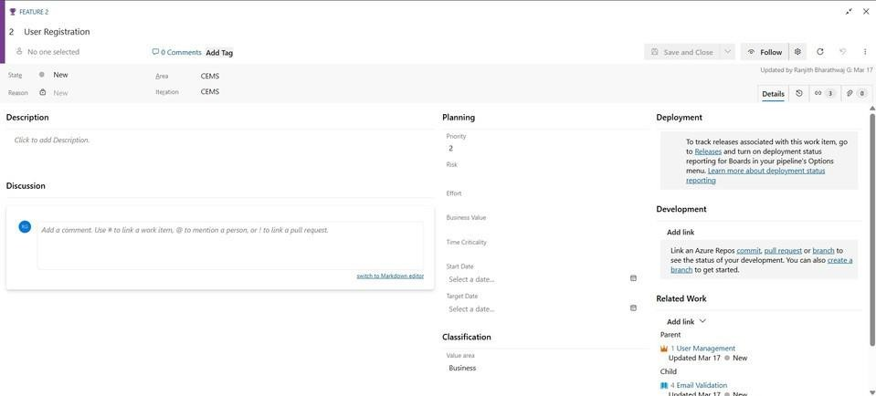

Fill in User Story Detail

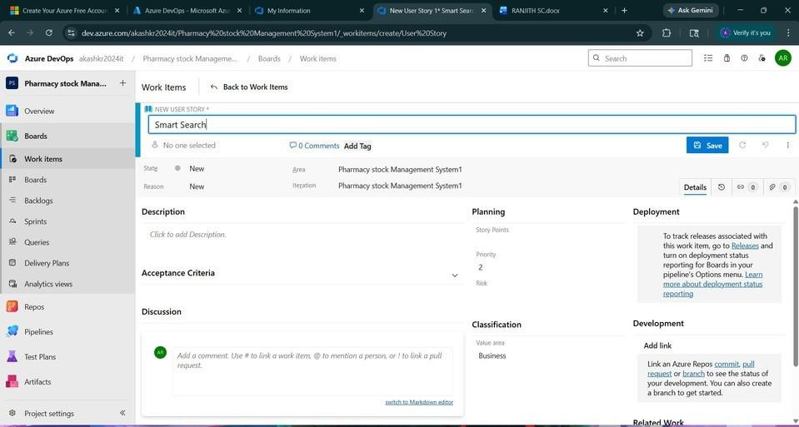

Result:
Thus, the creation of epics, features, user story and task has been created successfully.


EXPNO: 4
Create Epic,Features, User Stories, Task
SPRINT PLANNING

Aim:
To assign user story to specific sprint for the College event management Project.

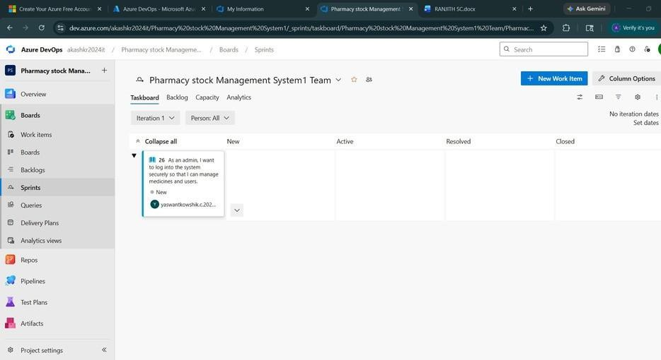
Sprint Planning: Sprint 1

Sprint 2
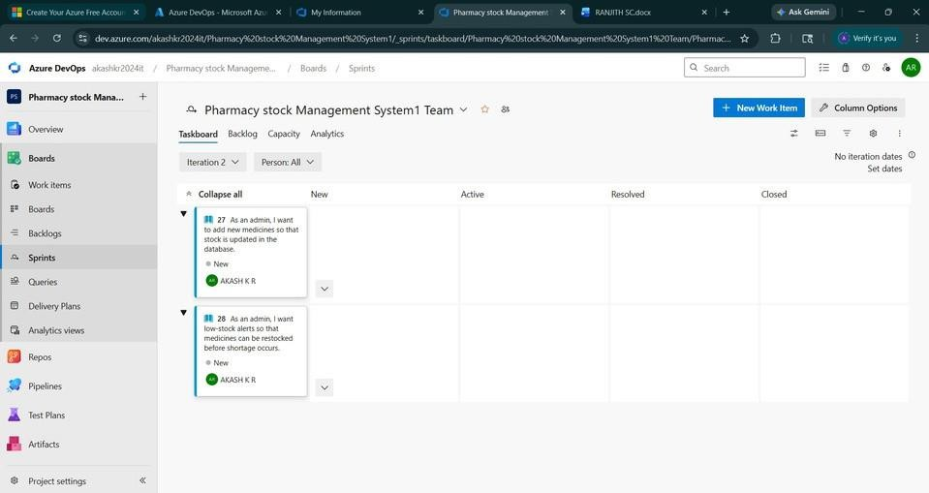

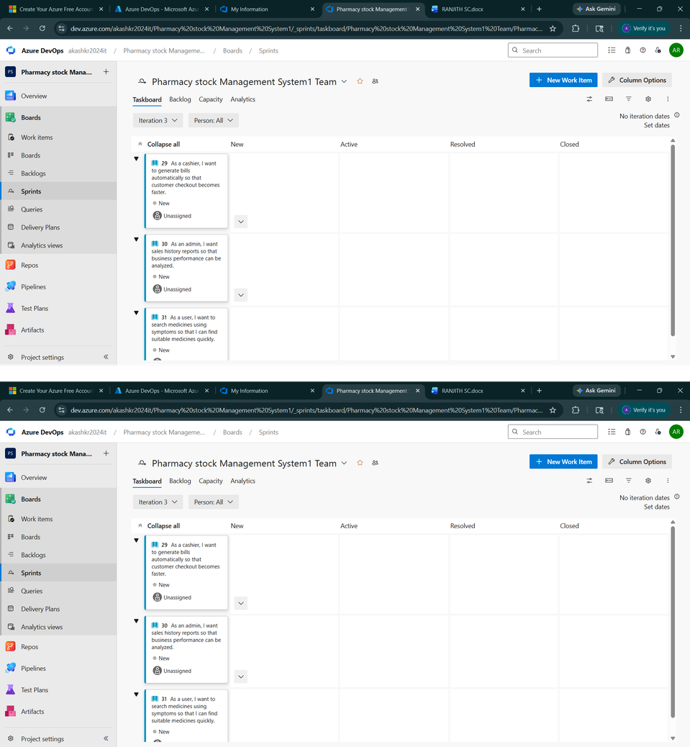
Sprint 3

Sprint 4

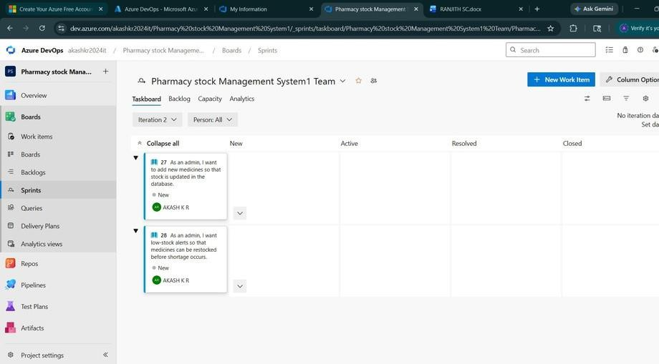

Result:
The Sprints are created for the College event management.


EXPNO: 5
Create Epic,Features, User Stories, Task
POKER ESTIMATION

Aim:
Create Poker Estimation for the user stories for Music Playlist Project.
Planning Poker Estimation: User Story ID: 20
Title: User Registration and Authentication

Description:
As a user, I want to register and log in securely so that I can access my personal music playlists and downloads.

Story Point Estimation: 8 Points Team Poker Votes:
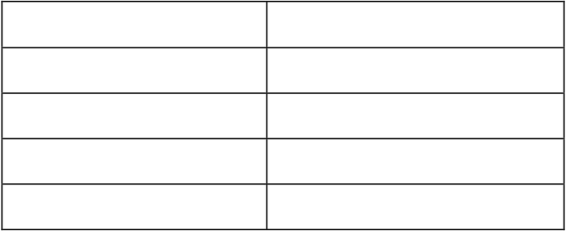
Team Member
Team Member 1
Team Member 2
Team Member 3
Team Member 4
Vote (Story Points) 5
8
8
8

Final Consensus: 8 Points
Reason for Estimation:

Risks:

- Includes multiple features: registration, login, session, logout
- Requires frontend + backend + database integration
- Security implementation (password hashing, authentication)
- Moderate complexity with high risk

- Security vulnerabilities
- Session management issues
- Integration challenges

Acceptance Criteria Covered:

- User registration with email & password
- Login with valid credentials
- Error message for invalid login
- Session maintained after login
- Logout functionality

Conclusion:
Finalagreed estimation is 8 story points based on complexity, effort, and risk.

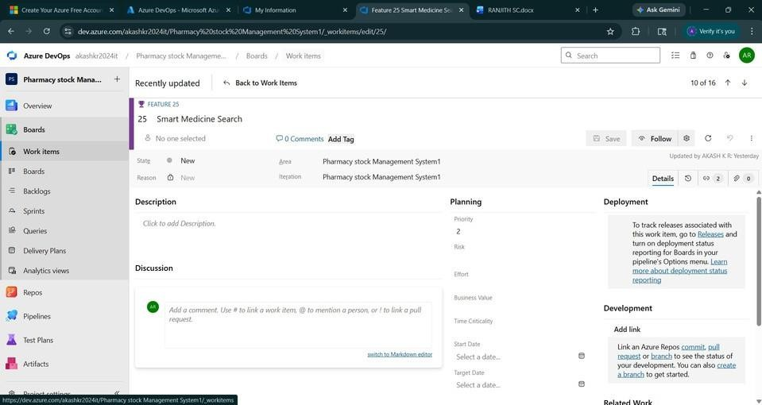

Result:
The Estimation/Story Points is created for the project using Poker Estimation.


EXPNO: 6
Create Epic,Features, User Stories, Task
DESIGNING CLASS AND SEQUENCE
DIAGRAMS FOR PROJECT
ARCHITECTURE

Aim:
To Design a Class Diagram and Sequence Diagram for the College Event Management.
Class Diagram:

Classes:

Key Attributes:

- Student
- Admin
- Event
- Registration
- Payment
- Certificate
- Notification
- Coordinator

Student: StudentId,Name,Email,Department Event: EventId,Title,Date,Venue,Category,Fee

Registration: RegistrationId,StudentId,E ventId,PaymentStatus Payment: PaymentId,Amount,Tran sactionStatus

Relationships:

- Student → registers for → Event
- Activity → conducted at → Venue
- Student → participates in → Competition
- Faculty Coordinator → manages → Event
- Organizer → schedules → Event
- Event → has → Participants
- Student → makes → Payment
- Student → receives → Ticket/Pass
- Student → submits → Feedback
- Student → receives → Notification
- Sponsor → sponsors → Event
- Event → awards → Certificate/Prize
- Department → organizes → Event
- Venue → allocated to → Event
- Student → joins → Team
- Team → participates in → Event
- Admin → approves → Event Request
- Event → publishes → Results
- Offer/Discount → applies to → Event Registration

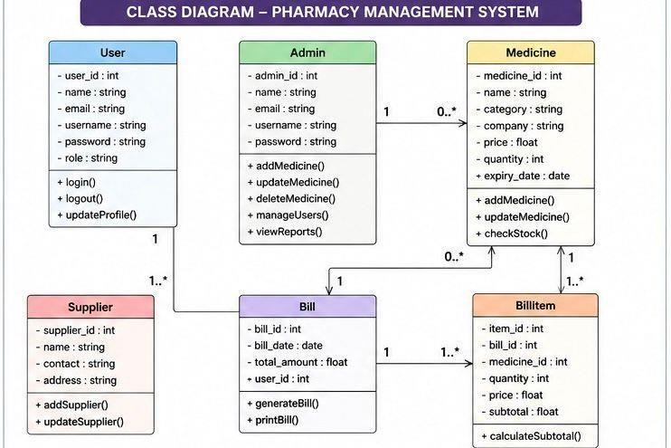
Sequence Diagram: Actors:
User→Frontend → Backend → Database → Auth Service
Steps:
- Userentersemail and password
- Frontend validates input (email format, password)
- Frontend sends login request to backend
- Backend validates request data
- Backend checks user in database

Condition: User Not Found
  - Backendreturns error: Invalid credentials

Condition: User Found
- Backendverifiespassword
- If password incorrect → return error
- If password correct → proceed
- Backend verifies user with auth service
- Backend generates JWT token
- Backend sets session (token expiry)
- Backend sends success response

- Frontend stores token
- Frontend redirects to dashboard
- User login successful

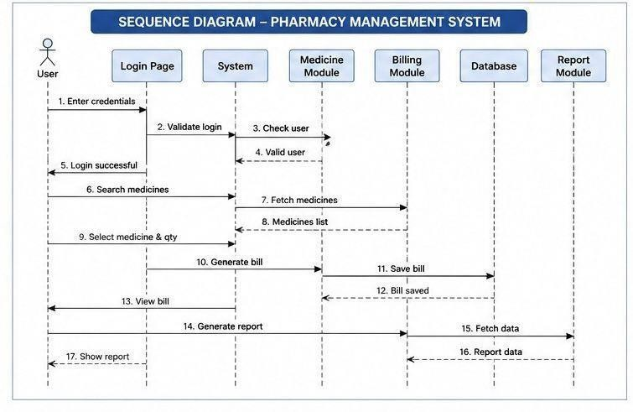

Result:The Class Diagram and Sequence Diagram is designed Successfully for the College Event Managemnt.


EXPNO: 7
Create Epic,Features, User Stories, Task
DESIGNING ARCHITECTURAL AND ER
DIAGRAMS FOR PROJECT STRUCTURE
Aim:
To Design an Architectural Diagram and ER Diagram for the given Project.

Architectural Diagram:

Layers:
- Client Layer
  - Browser
  - React App
  - Zustand (State Management)
- API Communication
  - Axios (HTTP Requests)
- Backend Layer
  - Express Server
  - Routes
  - Controllers
- Services
  - Clerk Authentication
  - File Upload(Cloudinary)
- Database Layer
  - MongooseModels
  - MongoDB

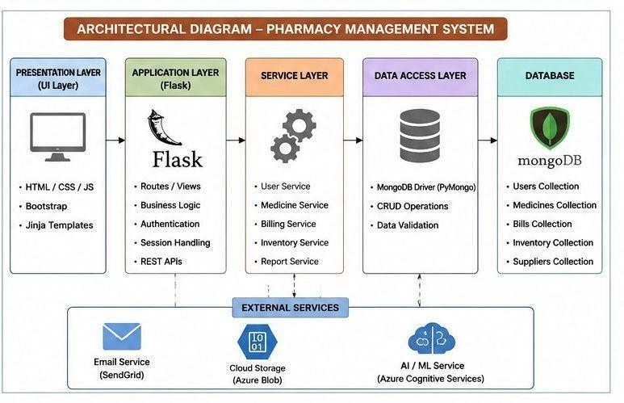
ER Diagram: Entities & Attributes: Student
- StudentId
- Name Email
- Department

Event:
- EventId
- Title
- Venue

- Date
- Fee

Registration
- registration
- amount
- status

Payment
- paymentId
- amount
- status

certificate

- certificateId

- issueDate Relationships
- Student registers for Event (M : N)
- Event includes Activity (1 : M)
- Activity conducted at Venue (M : 1)
- Student participates in Competition (M : N)
- Faculty Coordinator manages Event (1 : M)
- Organizer schedules Event (1 : M)
- Event has Participants (1 : M)
- Student makes Payment (1 : M)
- Student receives Ticket / Pass (1 : 1)
- Student submits Feedback (1 : M)
- Student receives Notification (1 : M)
- Sponsor sponsors Event (M : N)
- Event awards Certificate / Prize (1 : M)
- Department organizes Event (1 : M)
- Venue allocated to Event (1 : M)
- Student joins Team (M : N)
- Team participates in Event (M : N)
- Admin approves Event Request (1 : M)
- Event publishes Results (1 : 1)
- Offer / Discount applies to Event Registration (1 : M)

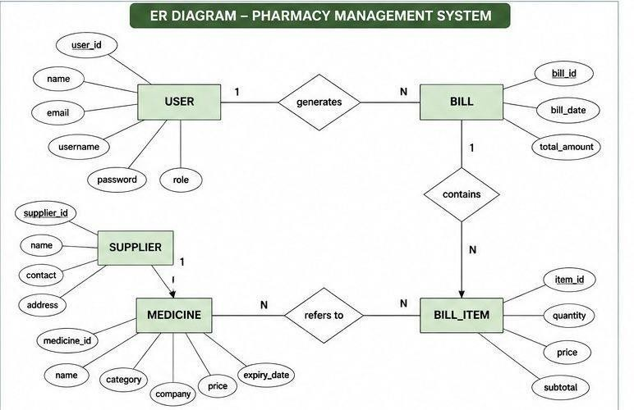

Result:The Architecture Diagram and ER Diagram is designed Successfully for the College Event Management.


EXP NO: 8
TESTING – TEST PLANS AND TEST CASES
Create Epic, Features, User Stories, Task
Aim:
Test Plans and Test Case and write two test cases for at least two user stories showcasing the
happy path and error scenarios in azure DevOps platform.

Test Planning and Test Case:
Test Case Design Procedure
- Understand Core Features of the Application
  - User Signup & Login
  - Viewing and Managing Playlists
  - Fetching Real-time Metadata
  - Editing playlists (rename, reorder, record)
  - Creating smart audio playlists based on categories (mood, genre, artist, etc.)
- Define User Interactions
  - Each test case simulates a real user behaviour (e.g., logging in, renaming a playlist, adding a song).
- Design Happy Path Test Cases
  - Focused on validatingthat all features function as expected under normal conditions.
  - Example: User logs insuccessfully, adds item to playlist, or creates a category-based playlist.
- Design Error Path Test Cases
  - Simulate negative or unexpected scenarios to test robustness and error handling.
  - Example: Login fails with invalid credentials, save fails when offline, no recommendations found.
- Break Down Steps and Expected Results
  - Each test case contains step-by-stepactions and a corresponding expected outcome.
  - Ensures clarity for both testers andautomation scripts.
- Use Clear Naming and IDs
  - Test cases are namedclearly (e.g., TC01 – Successful signup, TC06 – Add and Remove Songs from Playlist).
  - Helps in quick identification and linking to user stories or features.
- Separate Test Suites

  - Grouped test cases based on functionality (e.g., Login, Playlist Editing, Recommendation System).
  - Improves organization and test execution flow in Azure DevOps.
- Prioritize and Review
  - Critical useractions are marked high-priority.
  - Reviewed forcompleteness and traceability against feature requirements.

- New test plan
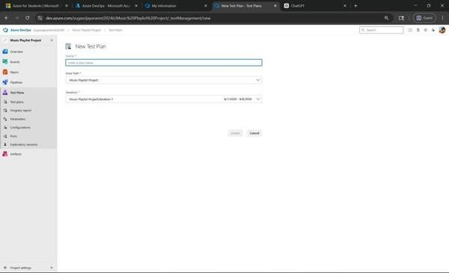

- Test suite
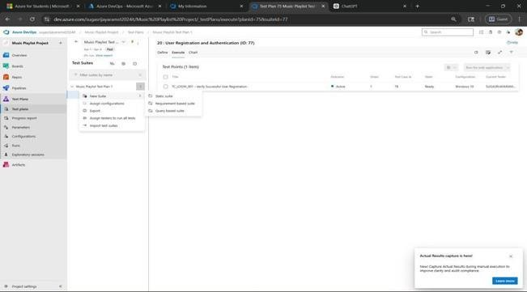

- Test case
Give two test cases for at least two user stories showcasing the happy path and error scenarios in azure DevOps platform.
Music Playlist Project – Test Plans
USER STORIES
  - As a user, I want to register and log in securely so that I can access my personal music playlists and downloads. (ID: 20).
  - As a user, I want to create and manage playlists so that I can organize my favourite songs easily (ID: 23).
Test Suites
Test Suit: TS01 - User Registration and Authentication (ID: 20)
- TC01 – User Registration Successfully w/o Error
  - Action:
    - Go tothe Sign-Uppage
    - Entervalid name,email, and password
    - Click"Sign Up"
  - Expected Results:
    - Sign-Up form isdisplayed
    - Fields accept valueswithout error
    - Account is createdsuccessfully
    - User is redirectedtodashboard
  - Type: Happy Path

- TC02 – User Registration Failed with Invalid User Details
  - Action:
    - Go tothe Sign-Up page
    - Enterinvalid details (empty fields / wrong email format / weak password)
    - Click"Sign Up"
  - Expected Results:
    - Validation errorsare displayed
    - Account is not created
  - Type: Error Path

- TC03 – User Login Successfully with Valid Credentials
  - Action:
    - Go toLogin page
    - Entervalid email and password
    - Click"Login"
  - Expected Results:
    - Login form isdisplayed
    - Credentials areaccepted
    - User is redirectedto dashboard
  - Type: Happy Path

- TC04 – Login with Invalid Credentials
  - Action:
    - Go toLogin page
    - Enterinvalid email or password
    - Click"Login"
  - Expected Results:
    - Input is accepted
    - Error message "Invalid username or password" is shown
- Type: Error Path

Test Suit: TS02 - Playlist Creation and Management (ID: 23)
- TC05 – Create Playlist Successfully
  - Action:
    - Login with valid credentials
    - Navigate to "My Playlists"
    - Click "Create Playlist"
    - Enter playlist name
    - Click "Save/Create"
  - Expected Results:
    - Playlist is created successfully
    - Playlist appears in list
  - Type: Happy Path

- TC06 – Add and Remove Songs from Playlist
  - Action:
    - Open anexisting playlist
    - Click "Add Song" and select a song
    - Click "Remove" on a song
  - Expected Results:
    - Song is added to playlist
    - Song is removed from playlist
  - Type: Happy Path

Test Cases
- TC08 – Delete Playlist and Save Changes
  - Action:
    - Navigate to "My Playlists"
    - Click "Delete" on a playlist
    - Confirm deletion
  - Expected Results:
    - Playlist is deleted successfully
    - Playlist is removed from list
    - Changes are saved
Type: Happy Path

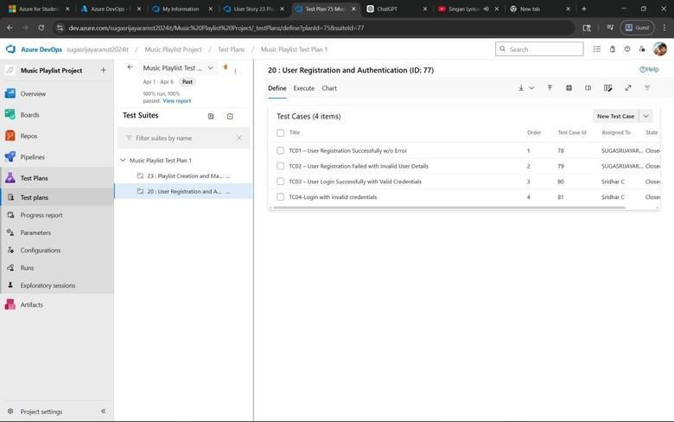

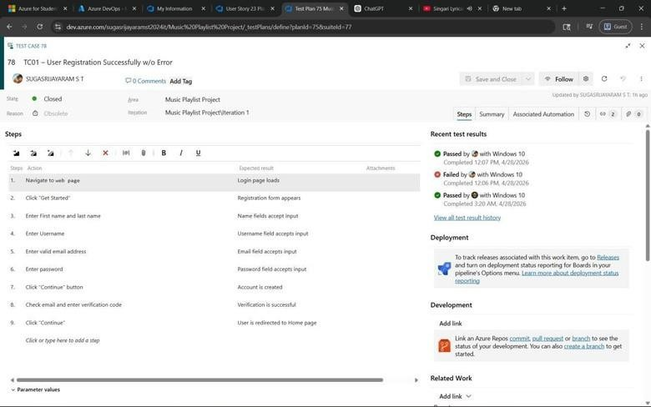

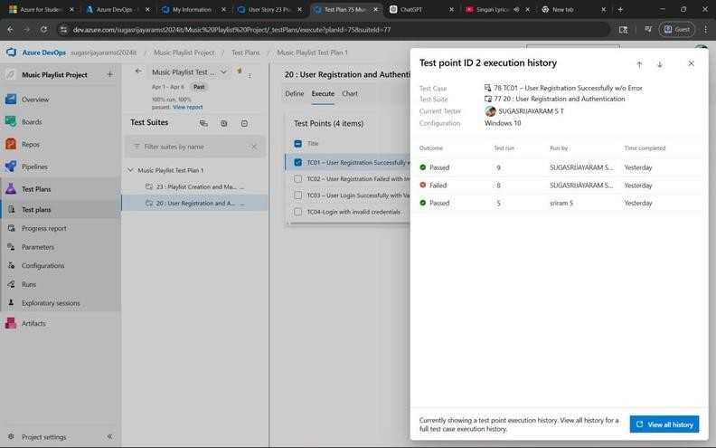

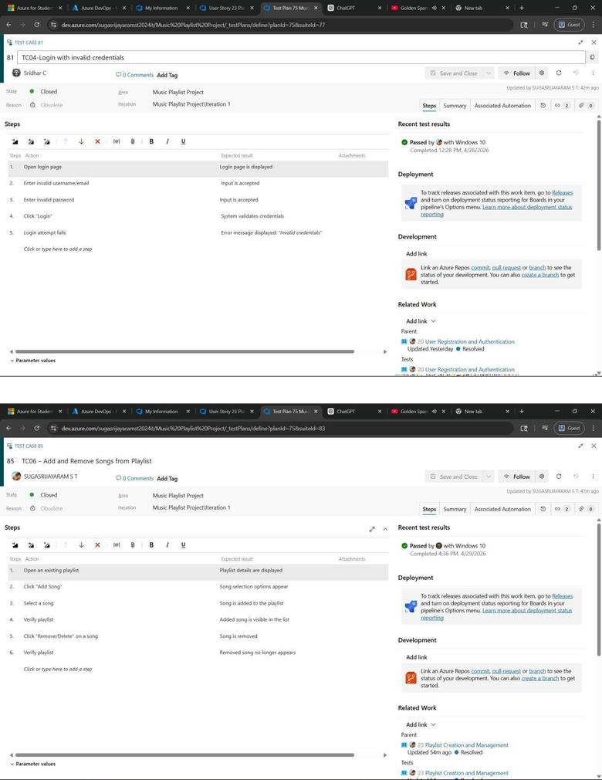

- Running the test cases
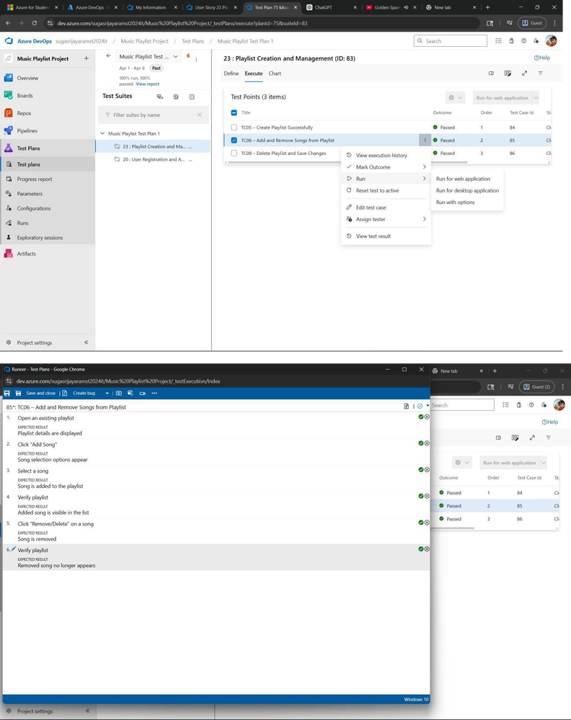

- Creating the bug
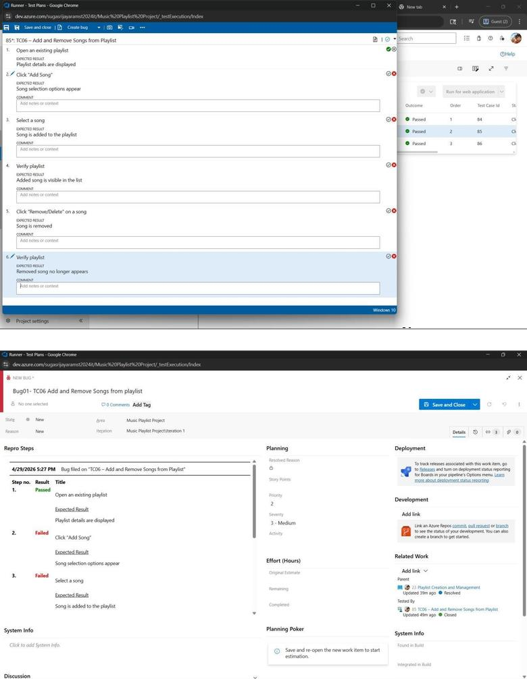

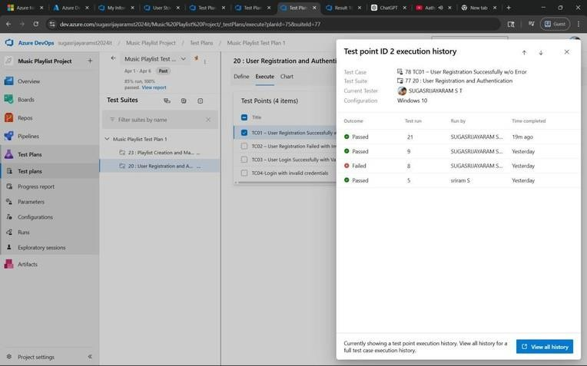
- Test case results

- Bug report
- Assigning bug to the developer and changing state to Active
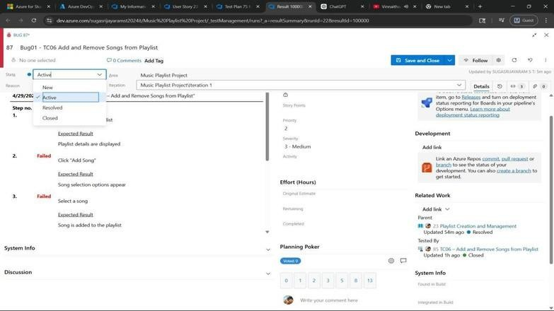

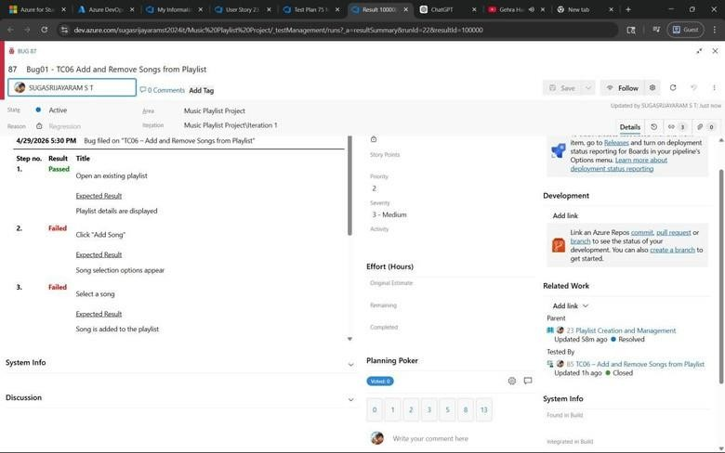

- Progress report

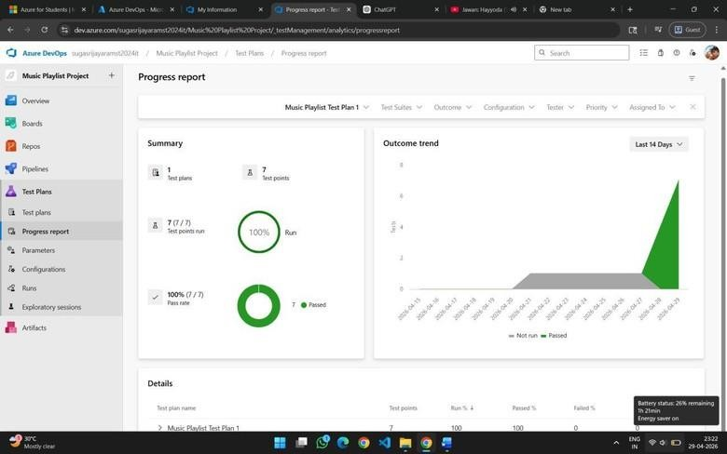

Result:
The test plans and test cases for the user stories is created in Azure DevOps with Happy Path and
Error Path.


EXPNO: 9
Create Epic,Features, User Stories, Task
LOAD TESTING AND PIPELINES

Aim:
To create an Azure Load Testing resource and run a load test to evaluate the performance of a target endpoint and to create and demonstrate an Azure DevOps pipeline for automating application builds, tests, and deployment.

Load Testing
Azure Load Testing:
Azure Load Testing allows you to simulate high traffic and stress tests for your web applications and APIs to understand how they perform under load. It helps identify performance bottlenecks, scalability issues, and optimize resource usage before deployment.

Steps to Create an Azure Load Testing Resource:
Before you run your first test, you need to create the Azure Load Testing resource:
- Sign in to Azure Portal
Go to https://portal.azure.com and log in.
- Create the Resource
  - Go to Create a resource → Search for “Azure Load Testing”.
  - Select Azure Load Testing and click Create.
- Fill in the Configuration Details
  - Subscription: Choose your Azure subscription.
  - Resource Group: Create new or select an existing one.
  - Name: Provide a unique name (no special characters).
  - Location: Choose the region for hosting the resource.
- (Optional) Configure tags for categorization and billing.
- Click Review + Create, then Create.
- Once deployment is complete, click Go to resource.

Steps to Create and Run a Load Test:
Once your resource is ready:
- Go to your Azure Load Testing resource and click Add HTTP requests > Create.
- Basics Tab
  - Test Name: Provide a unique name.
  - Description: (Optional) Add test purpose.
  - Run After Creation: Keep checked.
- Load Settings
  - Test URL: Enter the target endpoint (e.g., https://yourapi.com/products).

- Click Review + Create → Create to start the test.

Load Testing
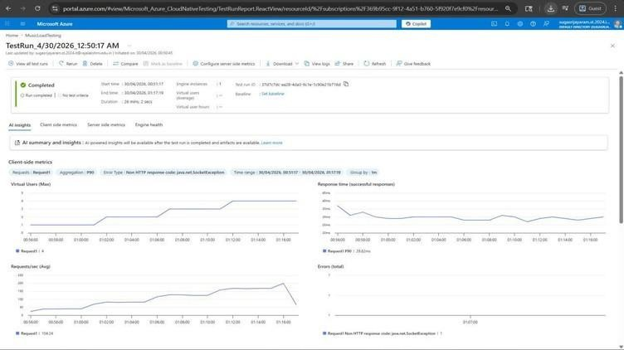

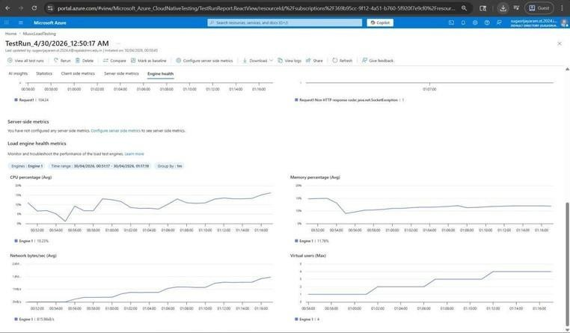

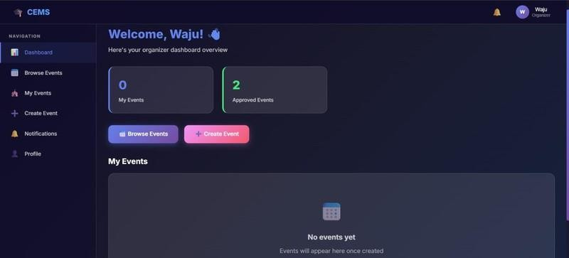

Pipelines Description:
Thisexperiment demonstrates how to connect a GitHub-hosted Flask-based music recommendation project with Azure DevOps. The pipeline will automatically install dependencies, run basic tests, and publish artifacts. This ensures that every commit triggers checks for reliability and smooth deployment.

Steps:
- Connect GitHub to Azure DevOps:
  - In Azure DevOps, create a new project.
  - Create a pipeline and select GitHub as the source.
  - Authorize access to your GitHub repository, ensuring that Azure DevOps can pull the repository for your pipeline.
- Create azure-pipelines.yml in Your Repo Root:
  - In your GitHub repository, create a new file called azure-pipelines.yml in the root directory.
  - Add the following basic pipeline configuration for Python and Flask:

yml Code
trigger:
- main

pool:
vmImage: 'ubuntu-latest'

variables:
NODE_VERSION: '20.19.x'
NPM_CACHE: '$(Pipeline.Workspace)/.npm' steps:
# ◆ Install Node.js (UPDATED TASK)
- task: UseNode@1 inputs:
version: $(NODE_VERSION)
displayName: 'Install Node.js'

# ◆ Cache npm (FIXED PATH)
- task: Cache@2
inputs:
key: 'npm | "$(Agent.OS)" | **/package-lock.json' path: $(NPM_CACHE)
displayName: 'Cache npm'

# ◆ Install Frontend Dependencies
- script: |
npm config set cache $(NPM_CACHE) --global npm ci
workingDirectory: frontend
displayName: 'Install Frontend Dependencies'

# ◆ Build Frontend (Vite)
- script: npm run build
workingDirectory: frontend displayName: 'Build Frontend'

# ◆ Frontend Tests (optional)

- script: npm test --if-present workingDirectory: frontend displayName: 'Run Frontend Tests'

# ◆ Install Backend Dependencies
- script: |
npm config set cache $(NPM_CACHE) --global npm ci
workingDirectory: backend
displayName: 'Install Backend Dependencies'

# ◆ Backend Tests
- script: npm test --if-present
workingDirectory: backend displayName: 'Run Backend Tests'

# ◆ Verify Frontend Build (fail early)
- script: |
if [ ! -d "frontend/dist" ]; then
echo "Build failed: dist folder not found" exit 1
fi
displayName: 'Verify Frontend Build'

# ◆ Archive Frontend
- task: ArchiveFiles@2
inputs:
rootFolderOrFile: 'frontend/dist' includeRootFolder: false archiveType: 'zip'
archiveFile: '$(Build.ArtifactStagingDirectory)/frontend.zip' displayName: 'Archive Frontend'
# ◆ Archive Backend
- task: ArchiveFiles@2
inputs:
rootFolderOrFile: 'backend' includeRootFolder: false archiveType: 'zip'
archiveFile: '$(Build.ArtifactStagingDirectory)/backend.zip' displayName: 'Archive Backend'
# ◆ Publish Artifacts

- task: PublishBuildArtifacts@1 inputs:
PathtoPublish: '$(Build.ArtifactStagingDirectory)' ArtifactName: 'drop'
displayName: 'Publish Artifacts'

- Run and Monitor Pipeline:
  - Commit changes to the main branch of your repository to trigger the pipeline in Azure DevOps.
  - Monitor the logs in the Azure DevOps portal to view logs, errors, or success messages and ensure everything runs smoothly.

Pipeline
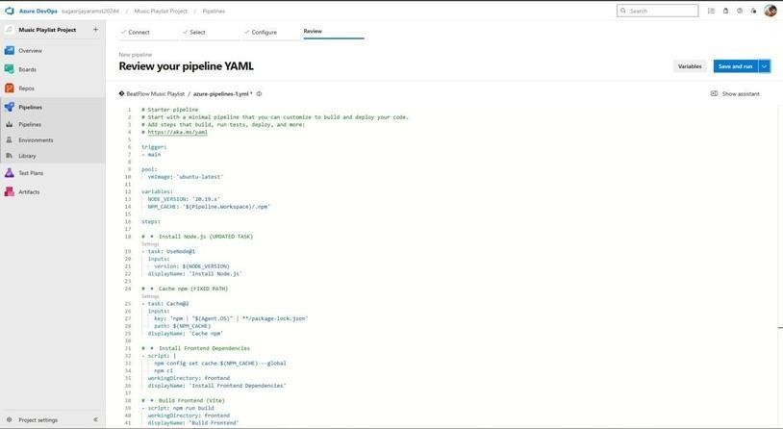

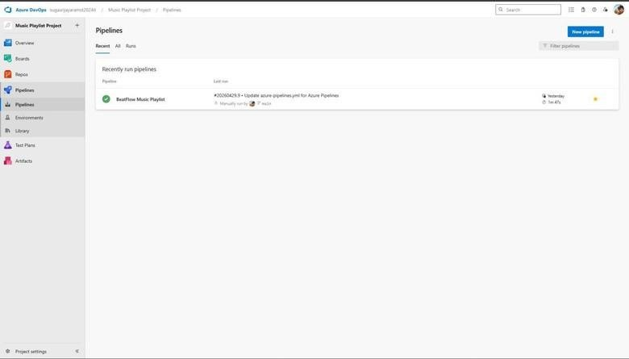

Result:
Successfully created the Azure Load Testing resource and executed a load test to assess the
performance of the specified endpoint and also demonstrated pipelines in azure devops.


EXPNO: 10
Create Epic, Features, User Stories, Task

GITHUB: PROJECT STRUCTURE & NAMING CONVENTIONS

Aim:
To provide a clear and organized view of the project's folder structure and file naming conventions, helping contributors and users easily understand, navigate, and extend the College Event Management.

GitHub Project Structure

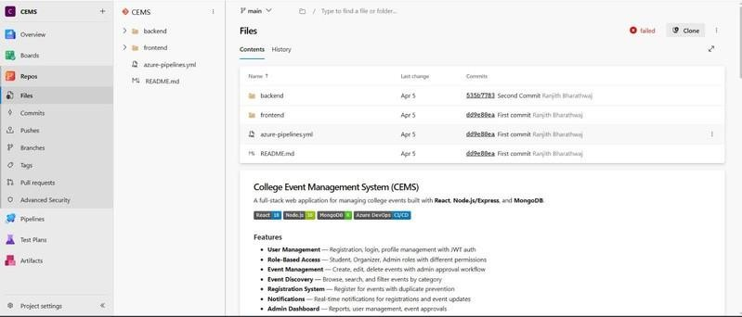

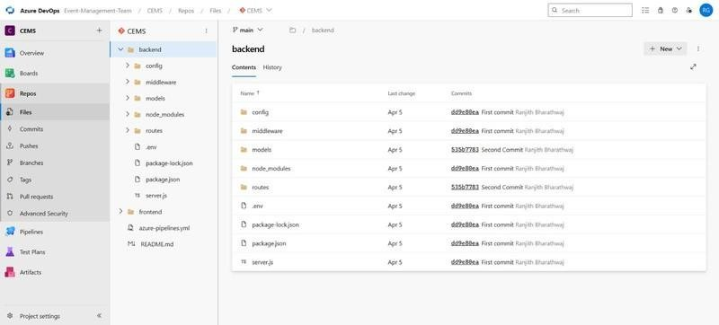

Result:
The GitHub repository clearly displays the organized project structure and consistent naming
conventions, making it easy for users and contributors to understand and navigate the codebase.

